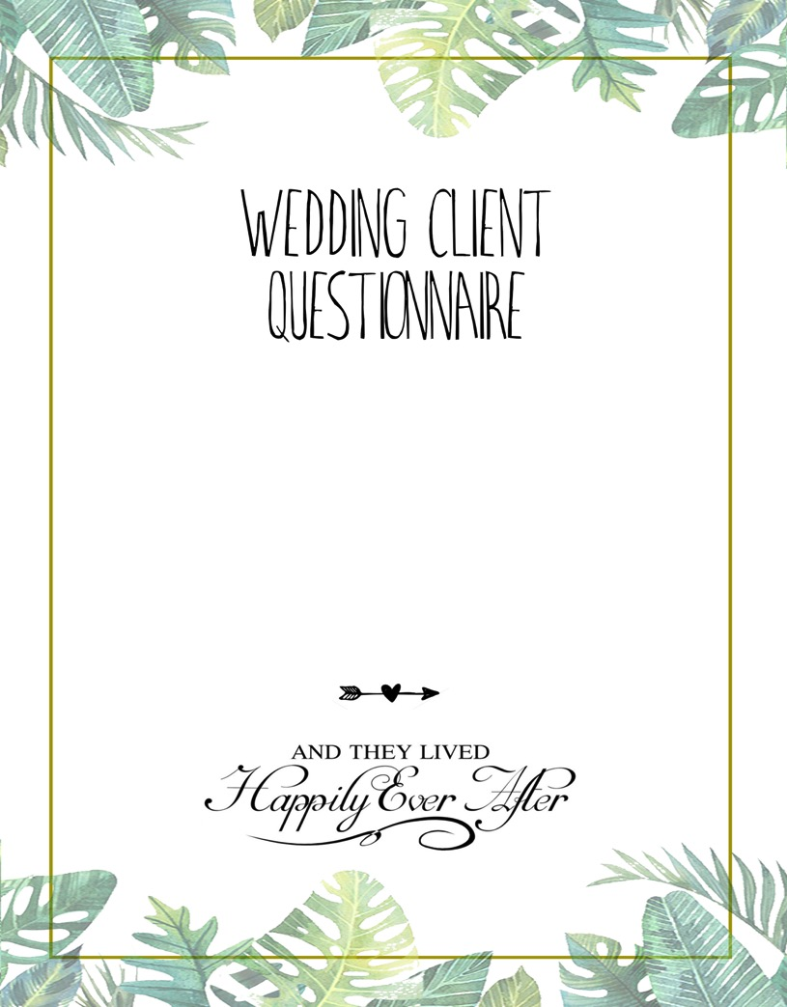

I enjoy working closely with my clients and offer a personalized experience including customized packages to suit your needs.
Please take a few minutes to complete the questionnaire to help me know a bit more about you as a couple and your event.

Bride

Bride’s Name:

D.O.B

Bride’s Phone Number:

Bride’s Email:

Skype Address if overseas:

Mother of the Bride:

Father of the Bride:

Maid of Honor:

Bridesmaids:

Flower Girl (s):

Siblings:

Where do you come from?

Where do your parents come from?
Mother:
Father:

Where were you born?

• Who will give you Away?

Groom

Groom’s Name:

D.O.B

Groom’s Phone Number:

Groom’s Email:

Skype Address if overseas:

Mother of the Groom:

Father of the Groom:

Best man:

Groom’s Men:

Ring Bearer:

Siblings:

Where do you come from?

Where do your parents come from?

Where were you born?

• How did you propose?

Bride and Groom

• What Religion are you? Please specify in detail of wedding traditions and about the style of wedding.

• What Passport do you Currently hold?

Bride
Groom

• Do you have any Allergies?

• Bride:

• Groom:

• How long have you been together?

• How did you meet? – Please give details

• Online dating

• Met by Chance

• Met at the Gym

• Have known each other since childhood

ABOUT YOUR WEDDING!

• Have you set a wedding date?

• Wedding Date: Example – 12 November 2015

Have You Chosen a Wedding Venue?
If yes Please give details:

• What is your Budget:

How many guests will attend your Wedding?

Do any Guests have disabilities?

• Do you desire to make Wedding invitations please attach a design and Example of Desired invitations

• Will you be doing your legal Documents in Bali?

• What kind of Priest would you like for your ceremony?

Christian Catholic Buddhist Hindu

What would you say is the style of your wedding is?

• Contemporary

• Theme

• Fun

• Other/Please Specify –

What will your color Theme be? Please attach a color palette.

Would you like to hire any of the options below?
(Please Highlight in Pink)

• Photographer
• Videographer
• Make Up Artist (Please Copy paste Pictures of make up inspo
• Hair Stylist (Please copy Paste Pictures of Hair Styles that you like)

• Will you have Speeches?

Will you and your Partner Give a Speech?

Who will Give Speeches? (Mum, Dad, Bridal party???) Please give details.

Ceremony Location?

Ceremony Start Time:
(as will be on Invitations)

Reception Start Time:

Reception Location if Different to Ceremony

Preparation Room:
Please specify what you will need on the day in your Room
Bride and Groom

Coat Hangers for Dress and wedding Attire
Extra Mirror
Food and Drinks
Mannequin what size

- How many people are included in your Bridal party? (Not including the bride/groom) – please Give detail and names, photos if Possible,

- Who will be sitting at the bridal Table?

- Will you have a Bridal Party Table?

Mother of the Bride:
Father of the Bride:
Mother of the Groom:
Father of the Groom:
Maid of Honor:
Best Man:
Grooms men:
Bride’s maids:
Flower Girl:
Ring Bearer:

Catering

Would you Like Welcome canapés?

What Kind of Food would you like to serve?
•Indonesian
•Balinese
•Western
•Italian
•Indian
•BBQ
Pasar Malam/ Night Market kart Style

Other

We also have Vegan and Gluten Free option
Do any guests Have allergies or dietry requirements.

Do you require a children’s menu or Baby Chairs?

Will your reception be:
• Standing cocktails party
• Seated Coursed meal
• Buffet
• Family Style
• Pasar malam/ Food Karts
• Coconut Fiesta
• Other – please Give details and see our catering menus

Cake & Cake Cutting

Will you be having a Cake? If so please attach Photos of your desired Cake

What Cake Flavors do you like?

Would You Like a Candy/Desserts Buffet/Bar? Please Give Details and Attach photo

We can Book you in for Cake tasting but only if you are Available 5 days prior to the Event.

Cake table inspiration?

What song will you play at your Cake Cutting

Table Setting

How would you like the table set ?
Free Seated or Seating Plan?

Please add photos and details on our Wedding flowers and Décor Worksheet or to this document

Round Tables, Long Tables, Picnic Setup??? Please send images for inspiration

Wedding Gifts and Fans /please ask about wedding souvenir Options

Would you like candles?
Jewels on the table
Glasses

- Champagne
- Wine Glasses
- Water Goblets

Extra Table Décor
Charger Plates or white Plates?

- Table Numbers?

- Napkin Color?

- Napkin Style?

- Gold or Silver Cutlery?

Other/Please Specify and Send Example

Beverages:

• Will there be a cocktail hour?

• Welcome Drinks?

• Do you desire a Champagne Tower?

• Will you be serving wine?

• What are your Favorite Cocktails?
He recommends
She Recommends

Please give details on what kind of cocktails you like
.
• Please also see our Cocktail Menu and packages

Wedding Flowers
• Please Attach your Wedding flowers inspiration
Photos and names of desired flowers?
What is your Wedding Flower Budget?

Music & Entertainment

• What kind of music Would you Like at your Wedding?
• Hip Hop, Rock, 90’s, Latin,
Please Specify and Make a list of Songs

Walking Down the Aisle Song Bride:
Walk Away Song:
Processional Music:
Cocktail Hours Music:
Grand Entrance Song:
First Dance Song:
Father Daughter Dance: Mother Son Dance:
Cake Cutting Music:

Would you like any Extra Entertainment?

Live Music
DJ
Gamelan
Balinese Dancing
Fire Dancers Fairies
Stilt Walkers
LED Dancers Angels
Latin Dancers
Magicians
Kids Corner
Evening Events
First Dance
Grand Entrance
Garter Toss Bouquet Toss Photo Session
Trash The Dress Sesh Get Away Car Speeches
Champagne Tower

We suggest to make one of your guests the MC for the evening or you can hire one.

MC:

Please specify any other Events that may happen during the evening that you would need help with.

